**SQLInclassActivity02**

Name :Vasanth Sai Aitha

919646291

Sid: S571903

CREATE TABLE COUNTRY CITY

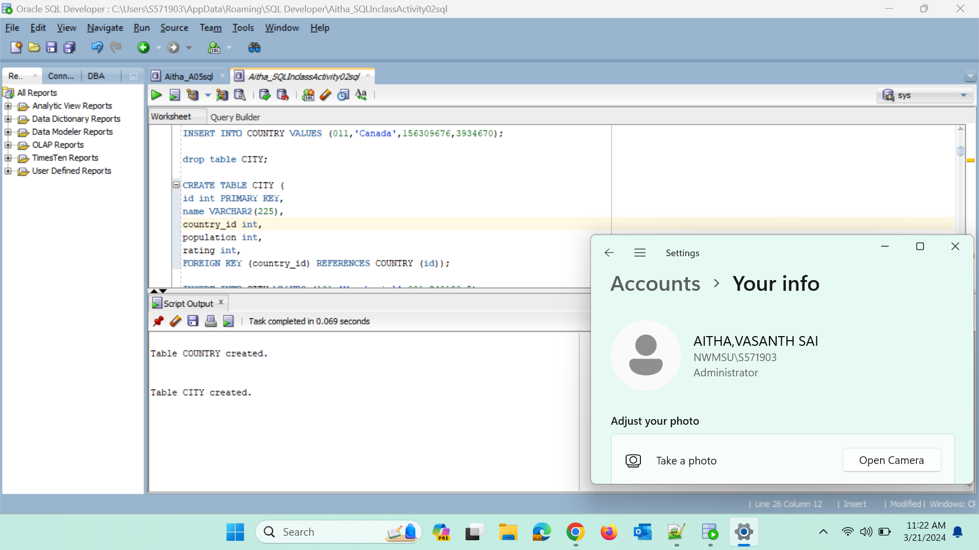

INSERT data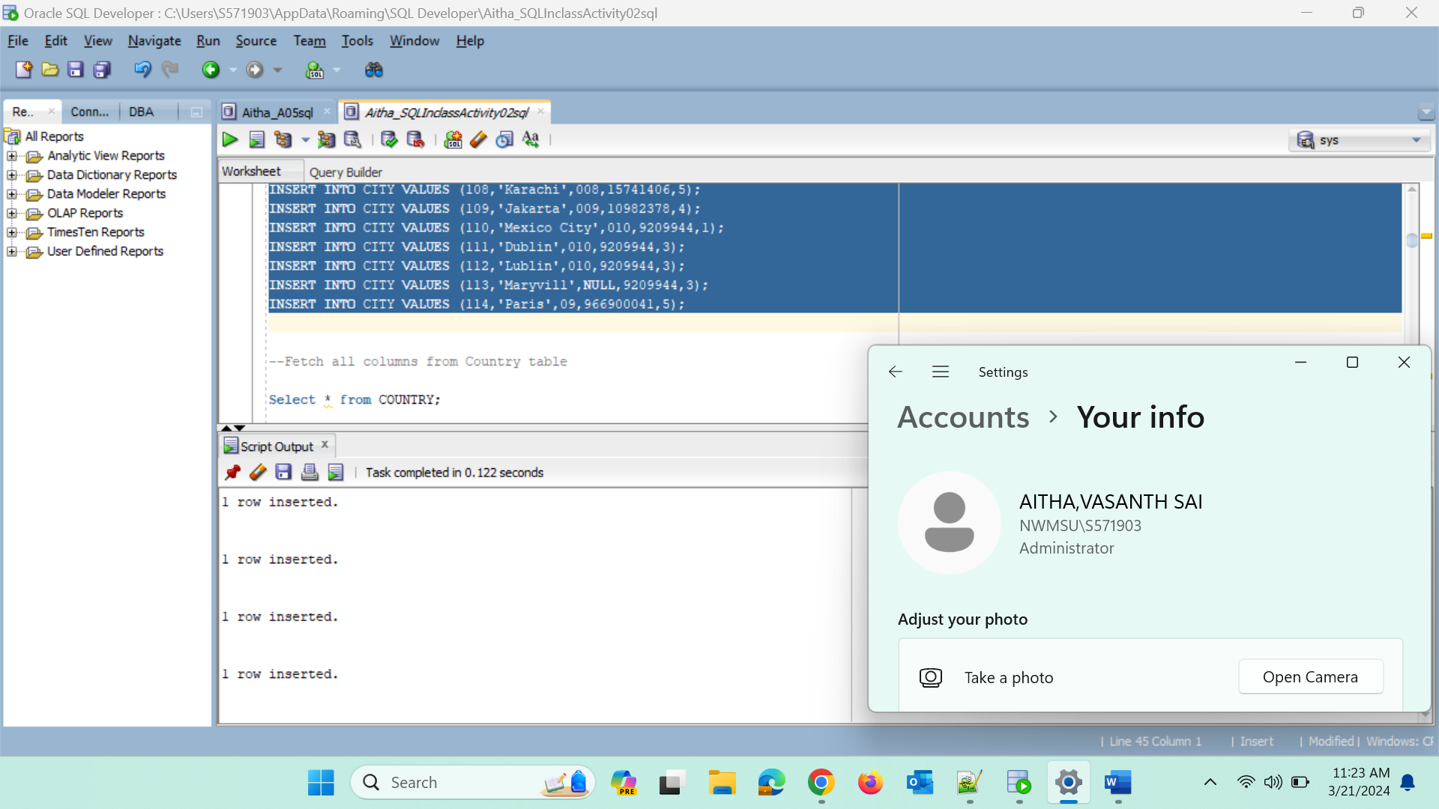

--Fetch all columns from Country table

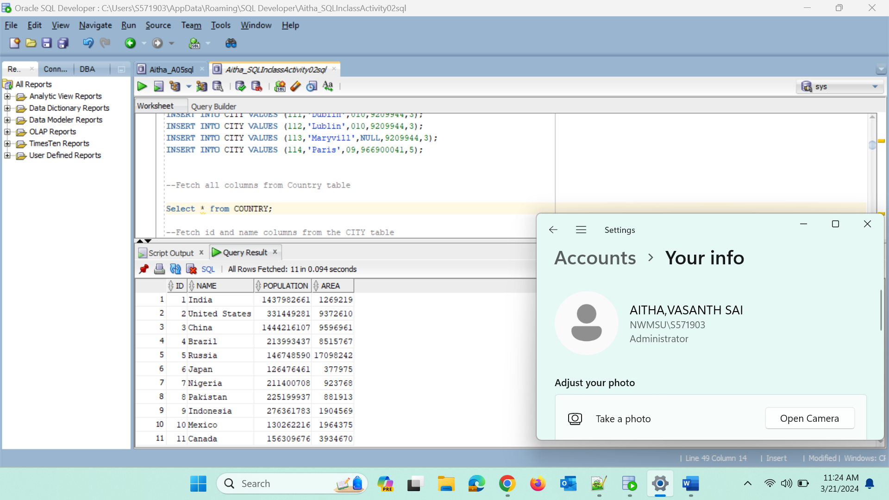

--Fetch id and name columns from the CITY table

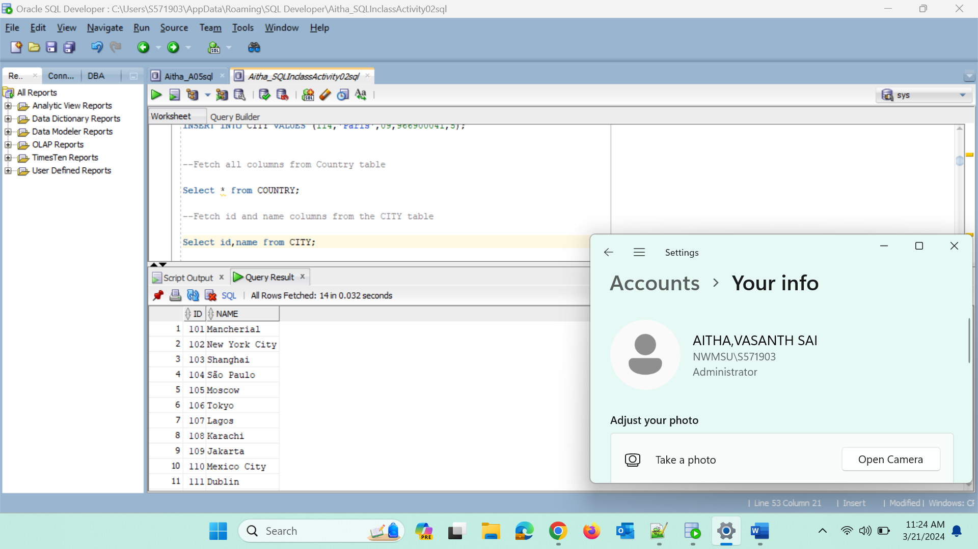

--Fetch city name Sorted by the rating column in default Ascending order

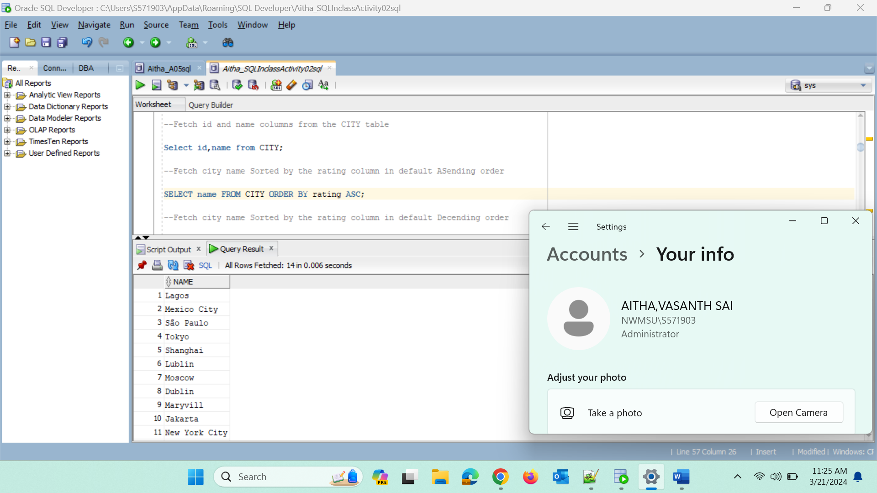

--Fetch city name Sorted by the rating column in default Descending order

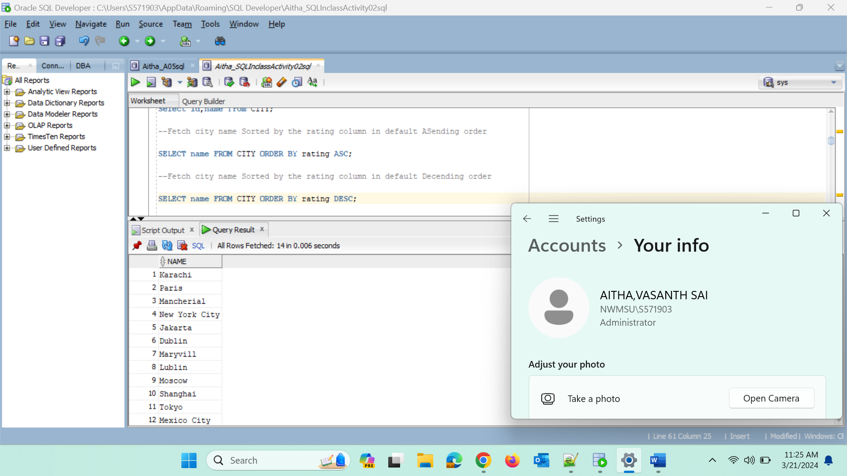

--Aliases

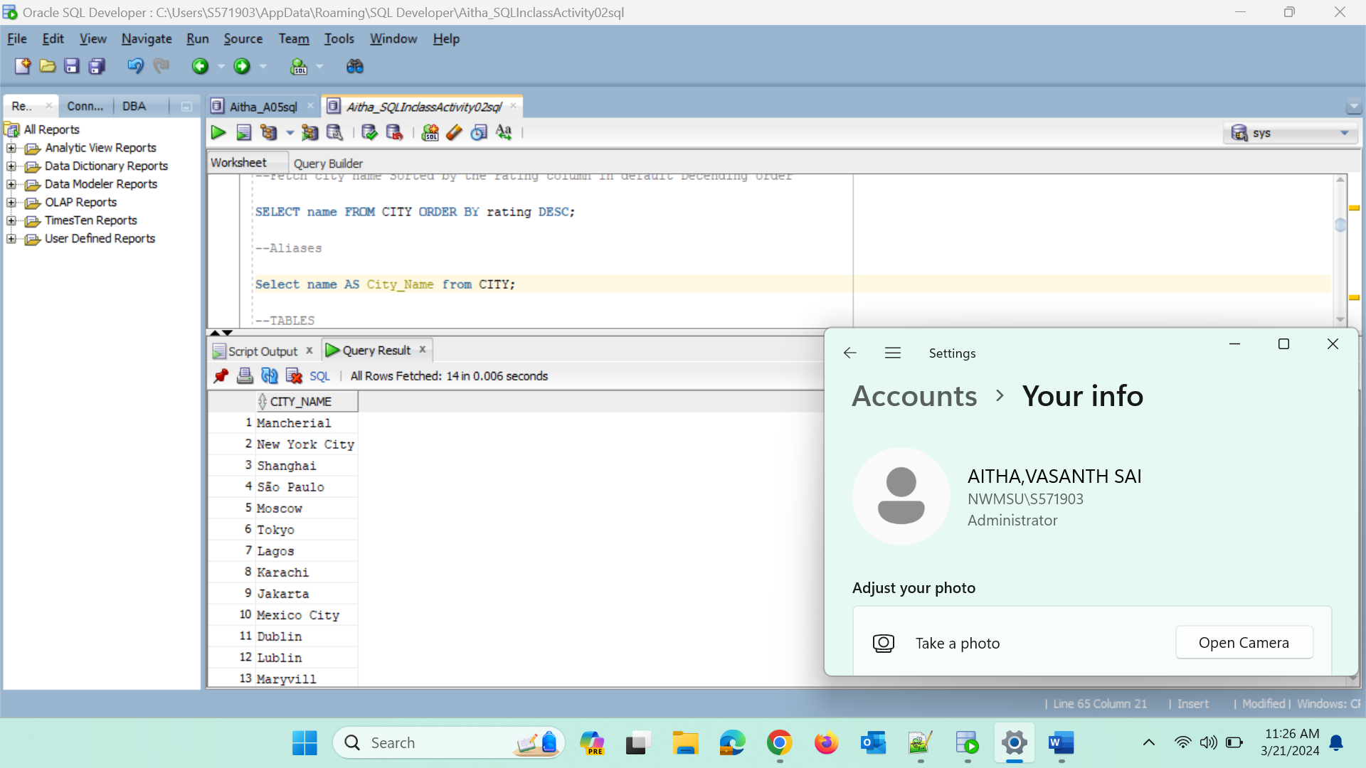

--TABLES

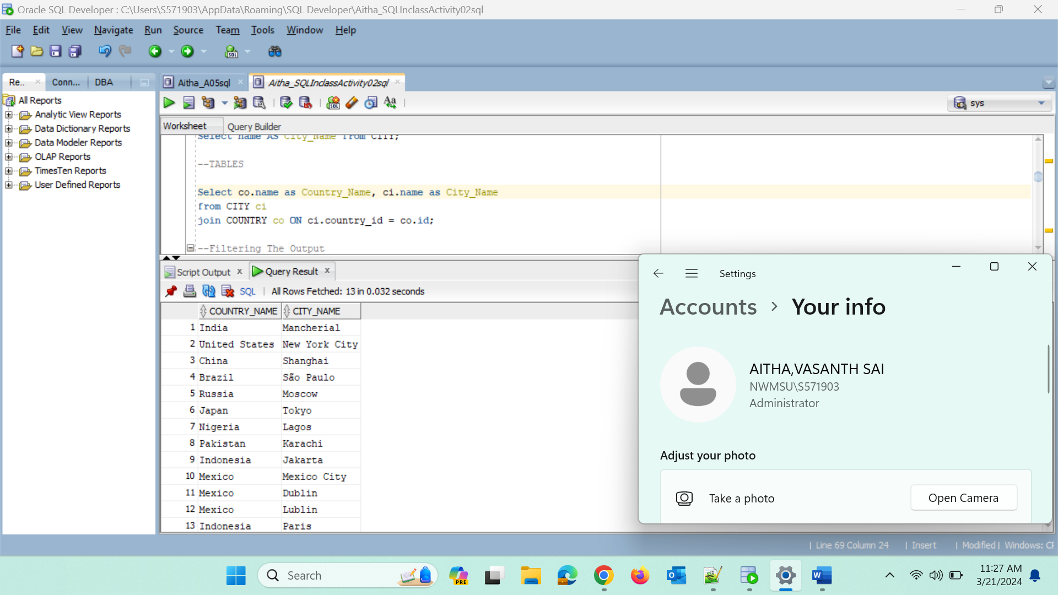

--Filtering The Output

-- Comparison operators

--Fetch names of city that have a rating above 3

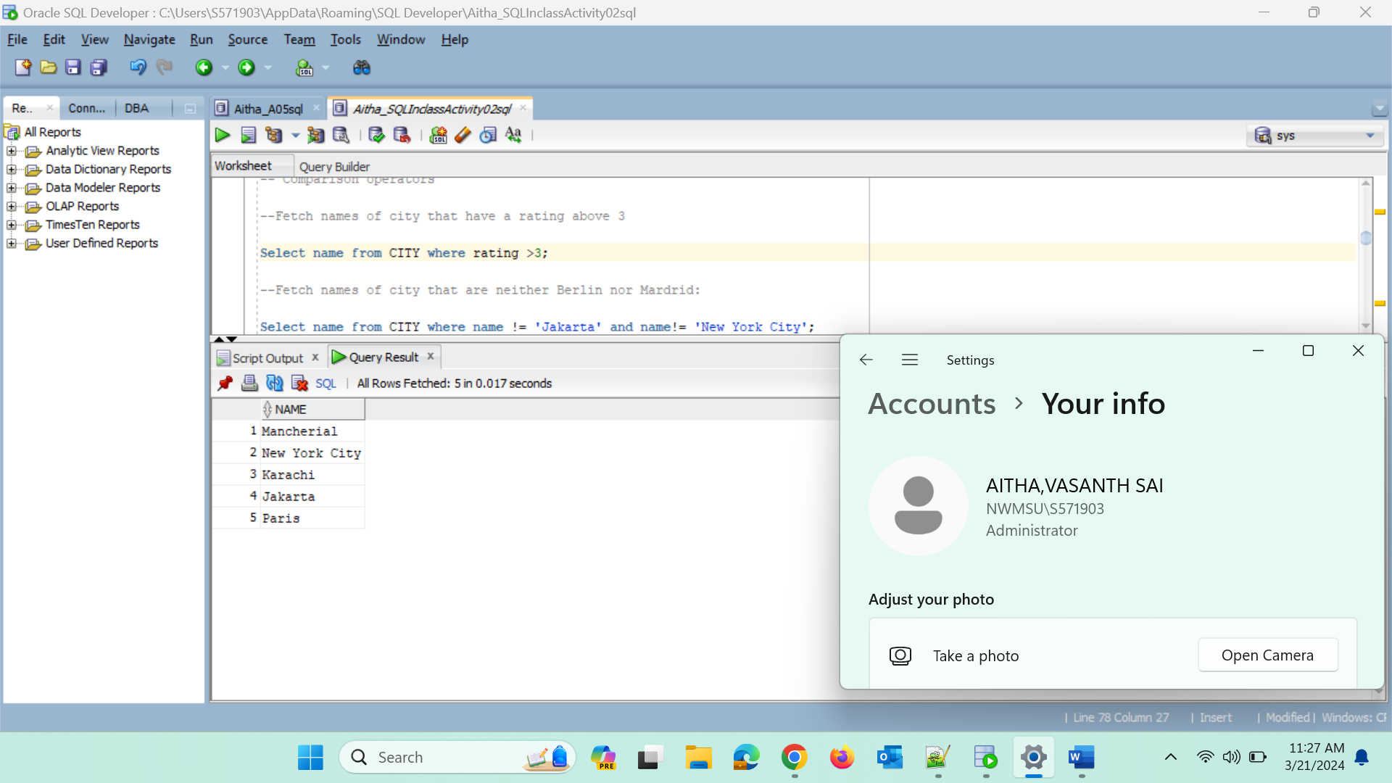

**--Fetch names of city that are neither Berlin nor Mardrid:**

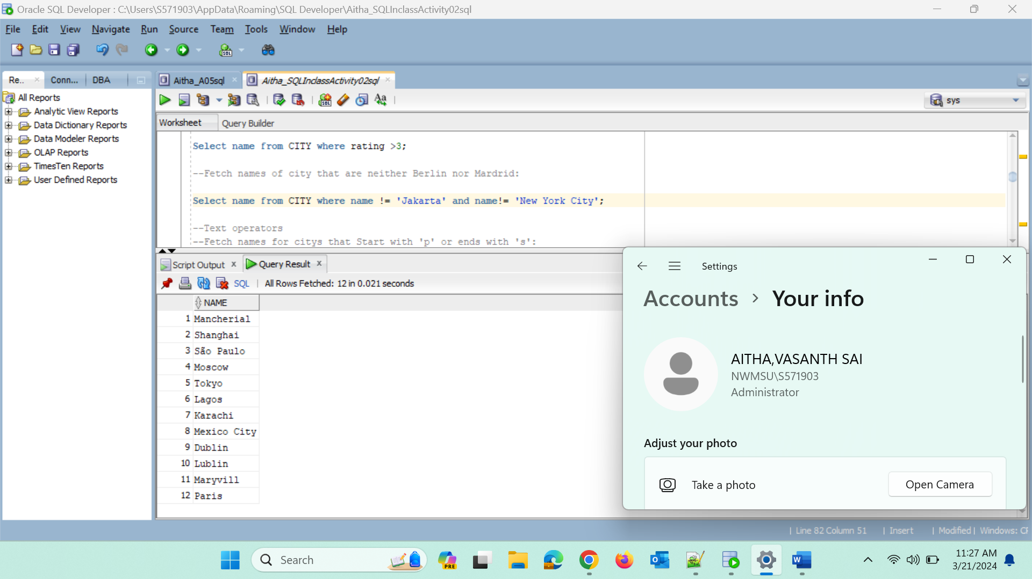

**--Text operators**

**--Fetch names for cities that Start with 'p' or ends with 's':**

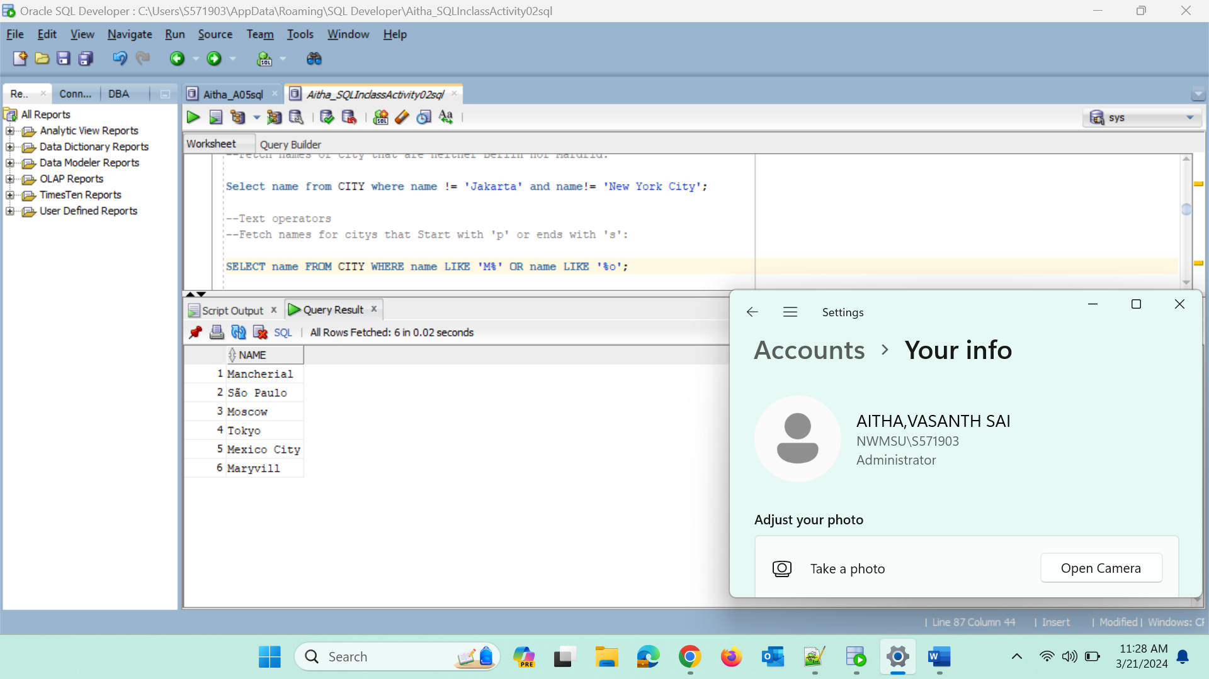

**--Fetch names of cities that starts with any latter followed by 'ublin';**

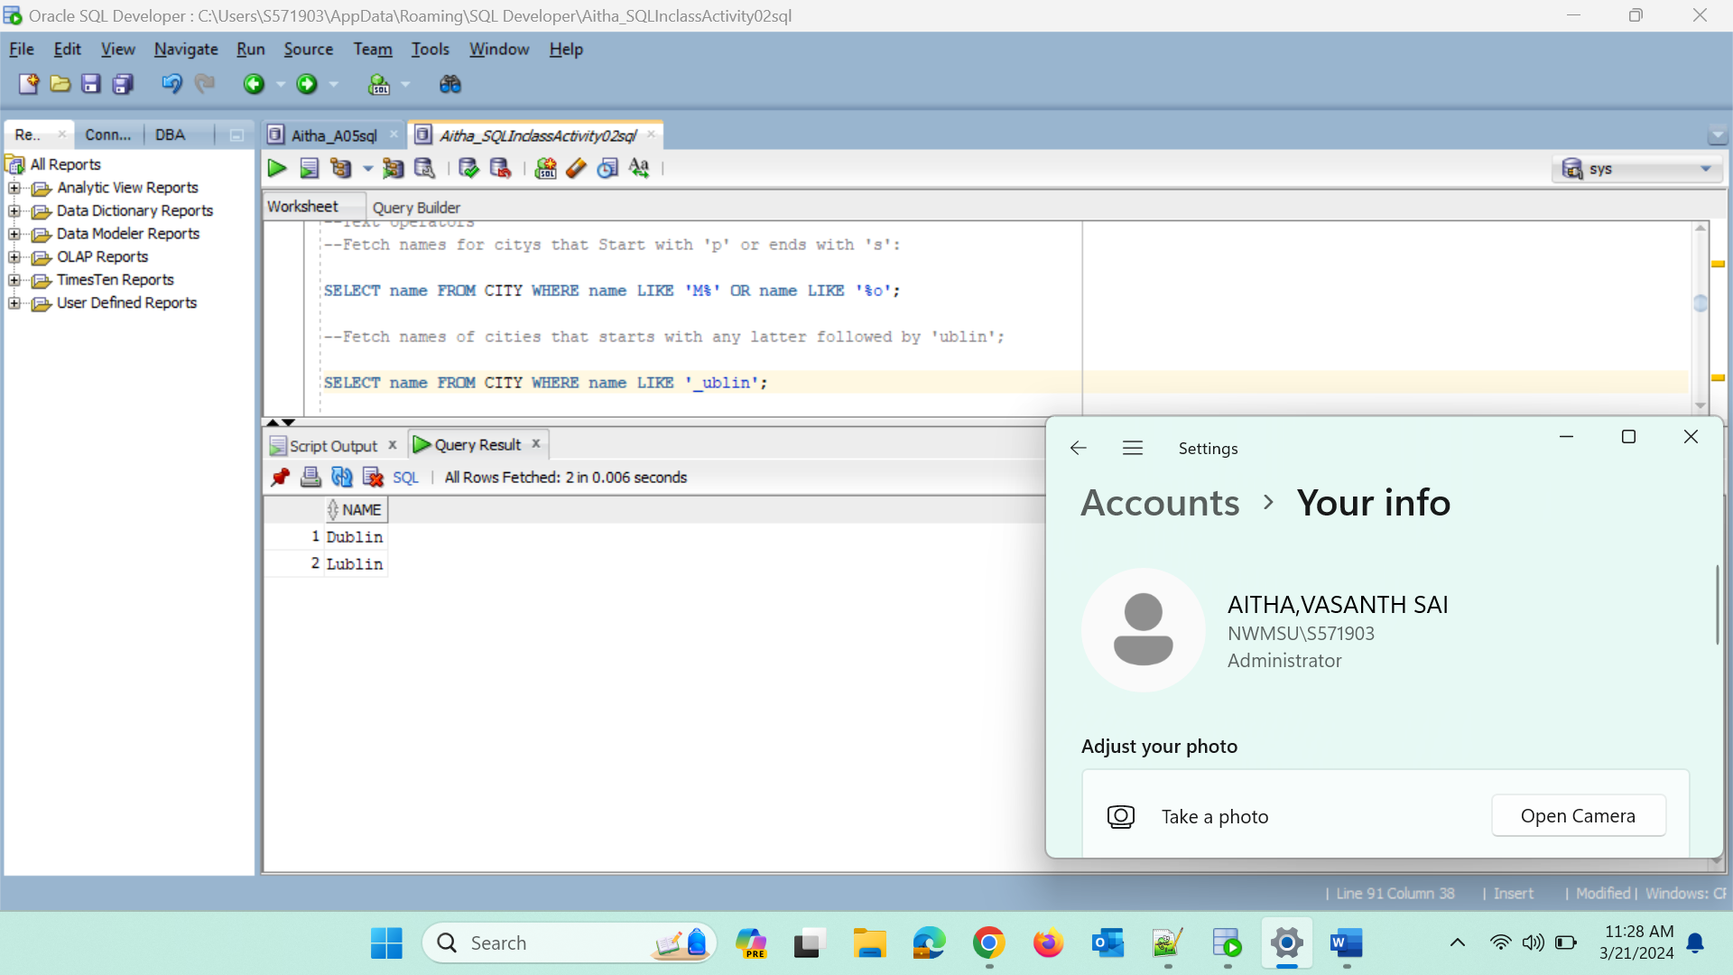

**--Other Operators**

**--Fetch names of cities that have a population between 500k and 5M:**

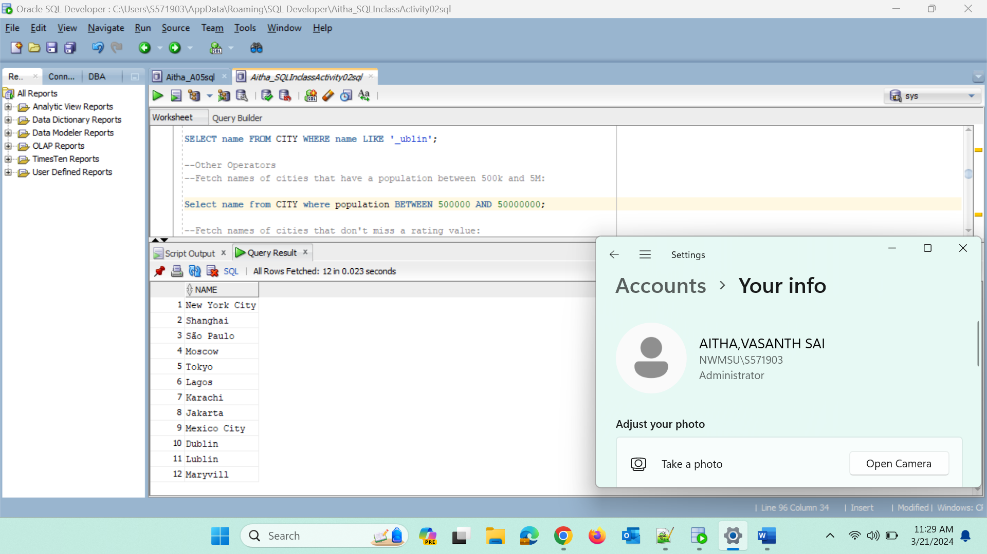

**--Fetch names of cities that don't miss a rating value:**

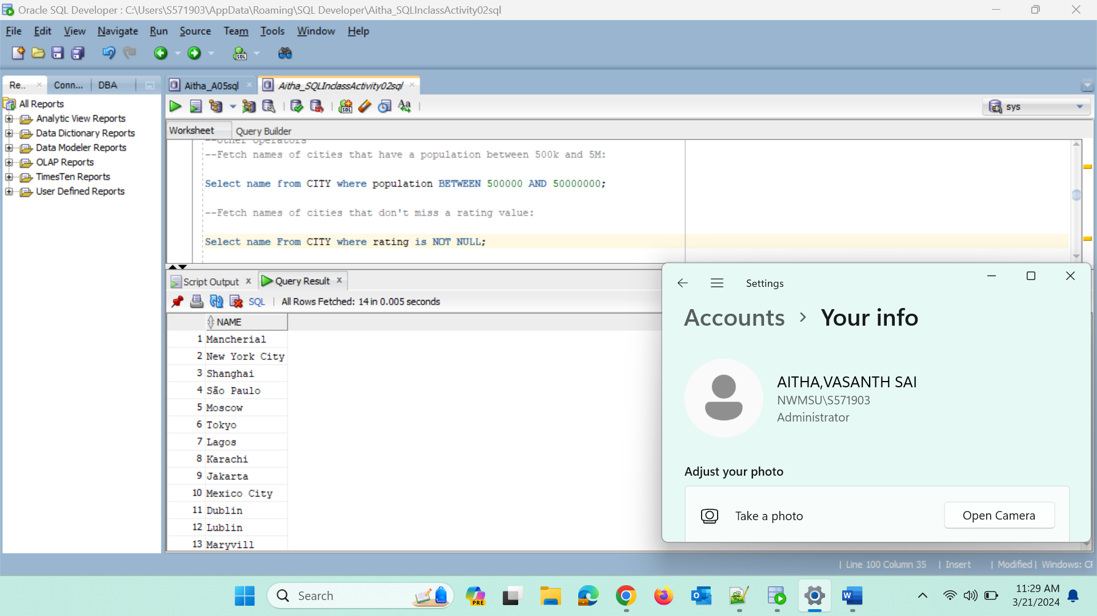

**--Fetch names of cities that are in countries with IDS 001, 003, 005:**

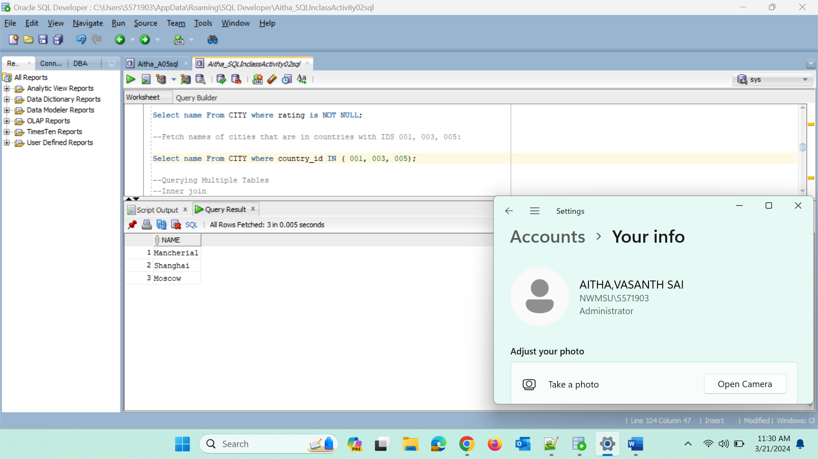

**--Querying Multiple Tables**

**--Inner join**

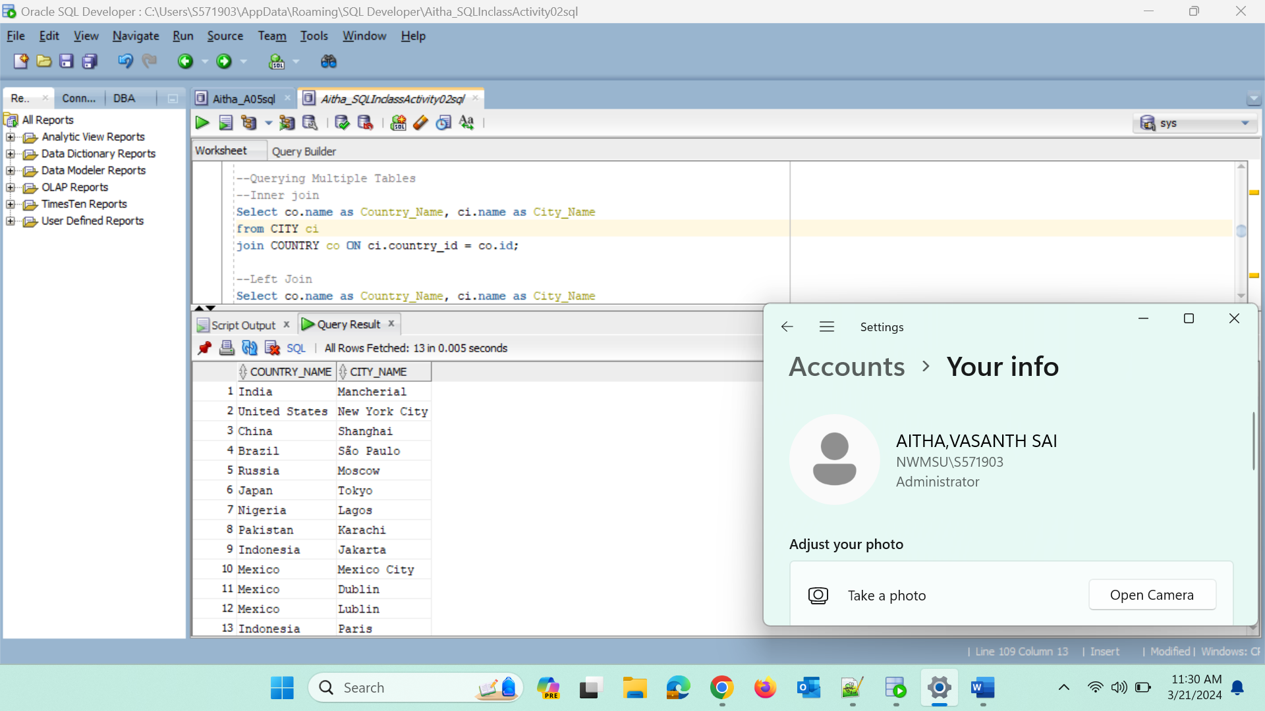

**--Left Join**

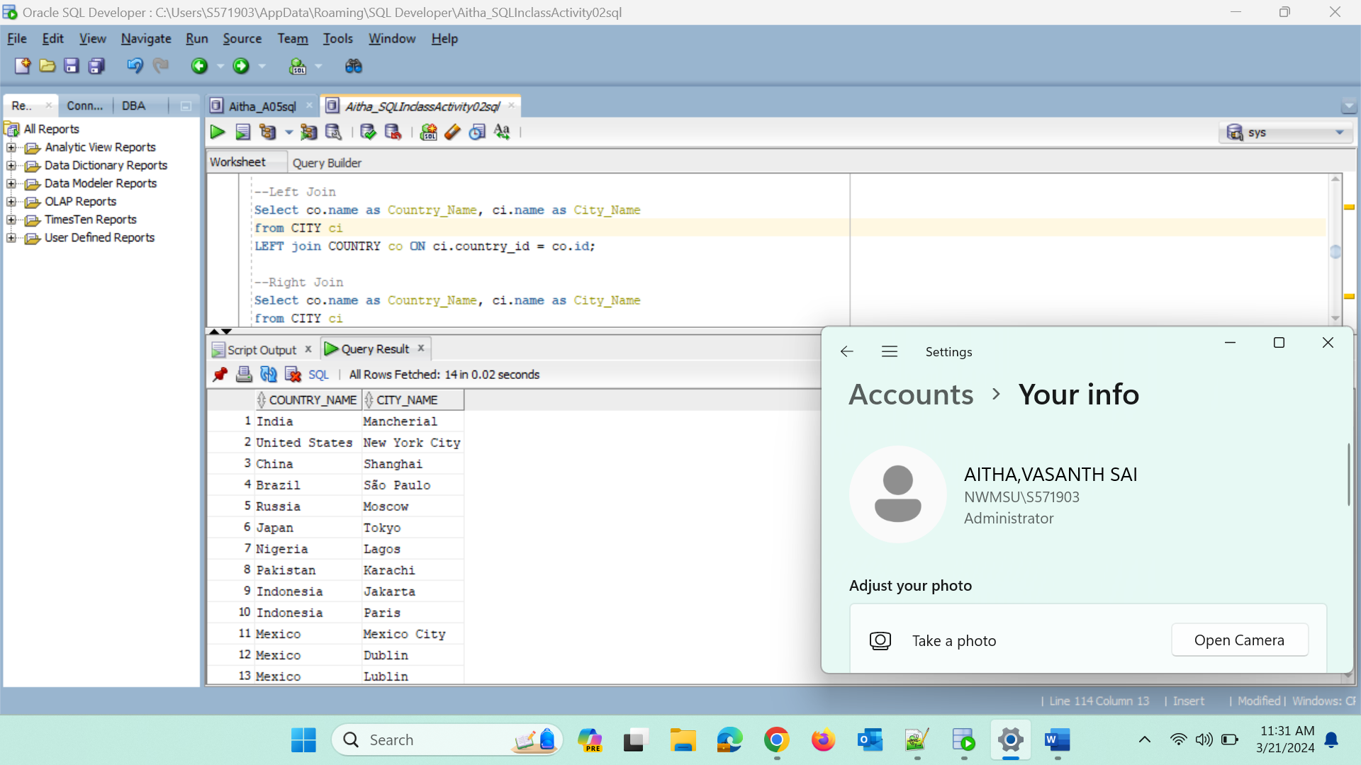

**--Right Join**

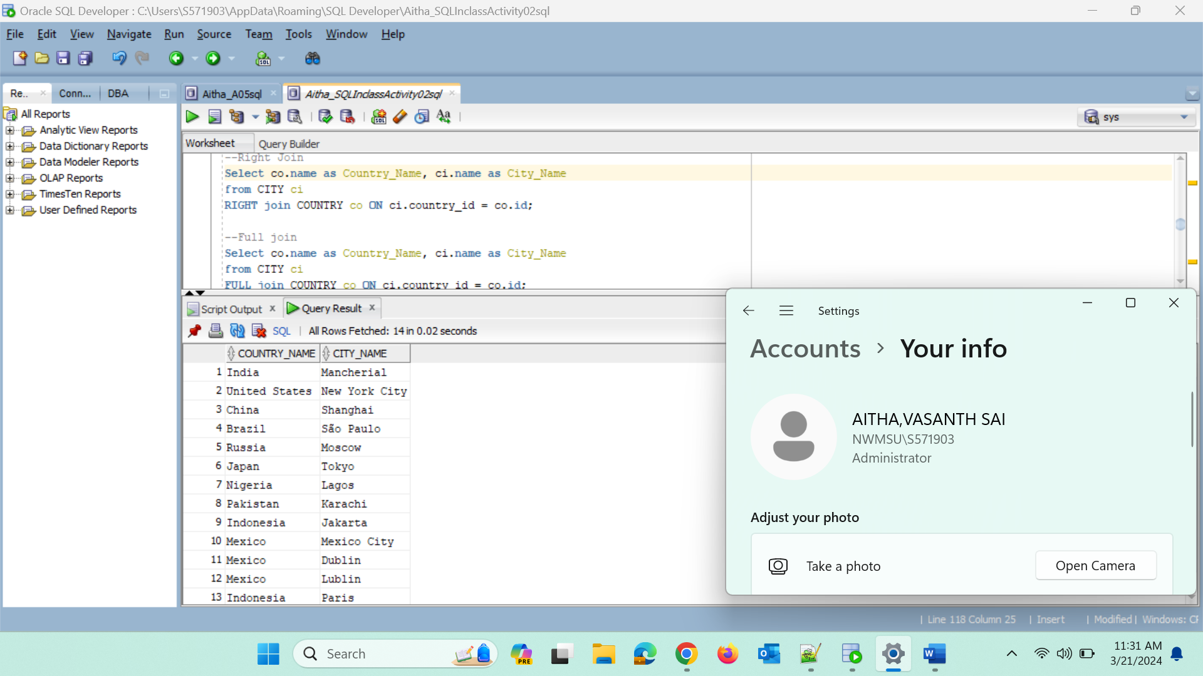

**--Full join**

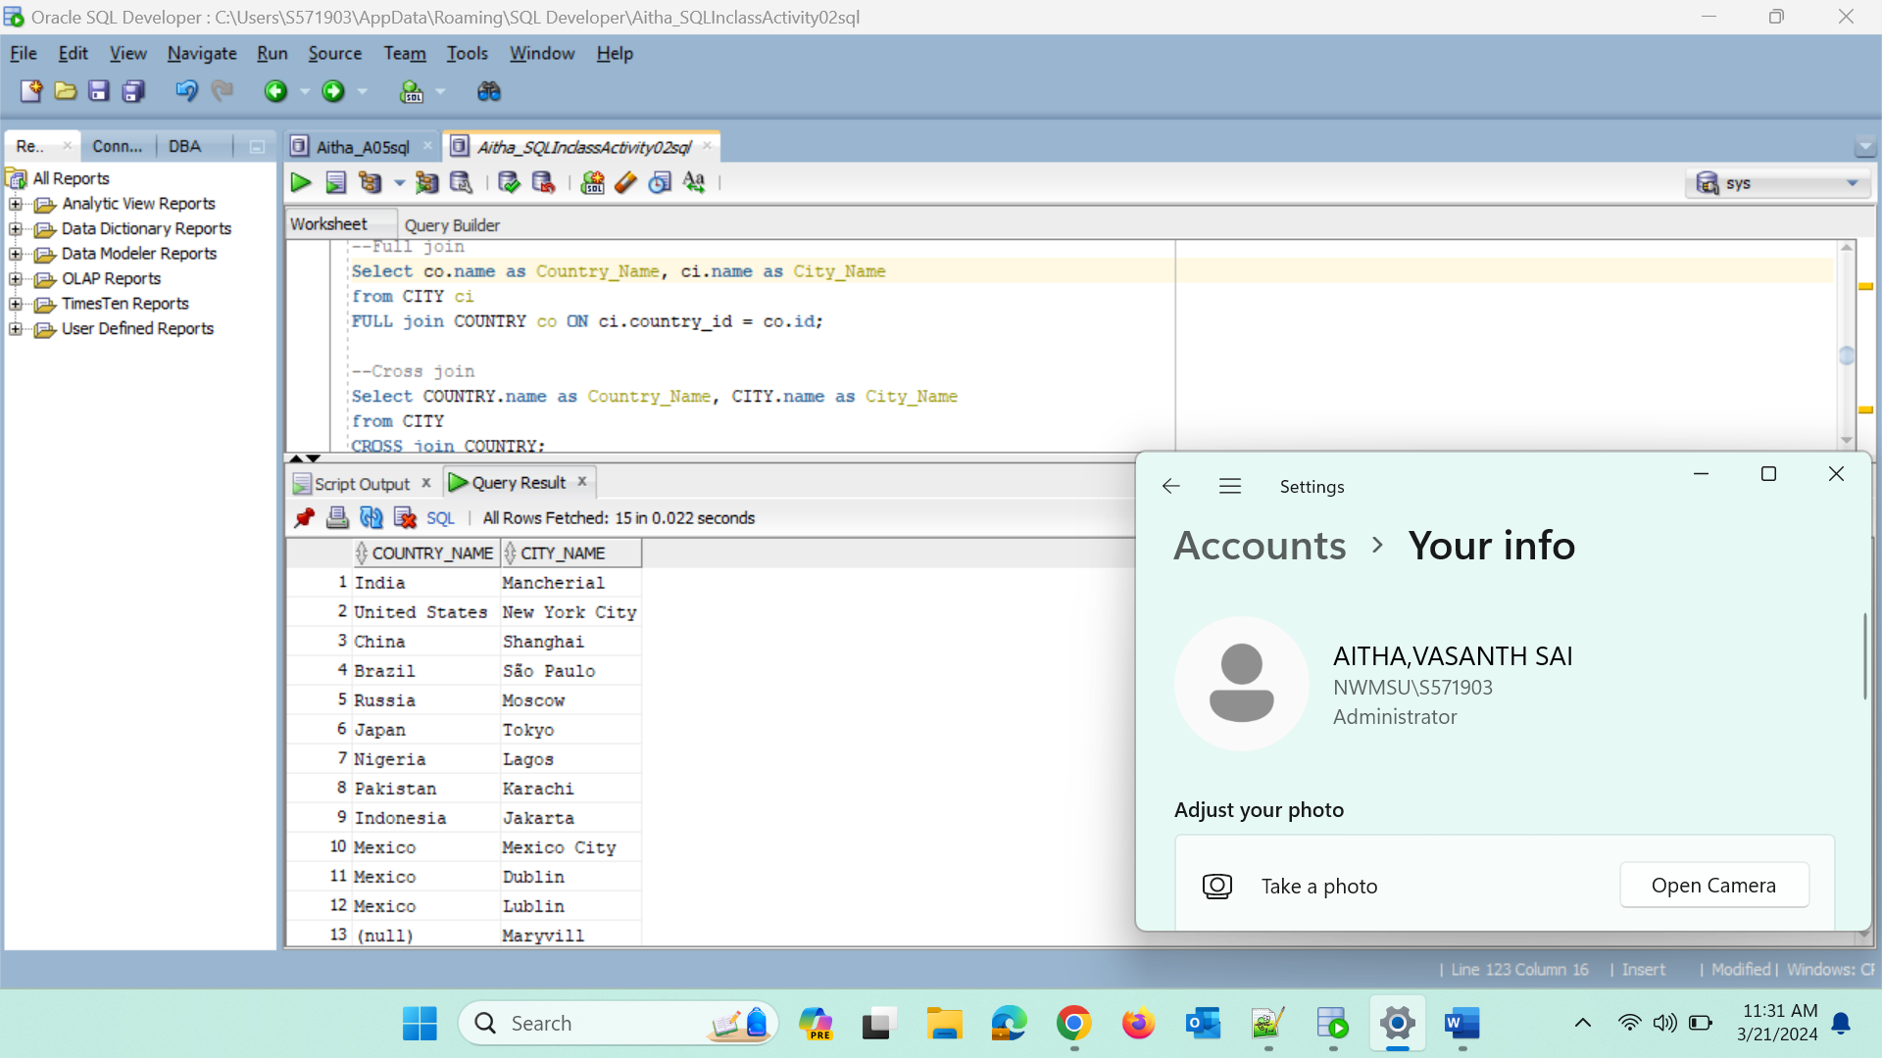

**--Cross join**

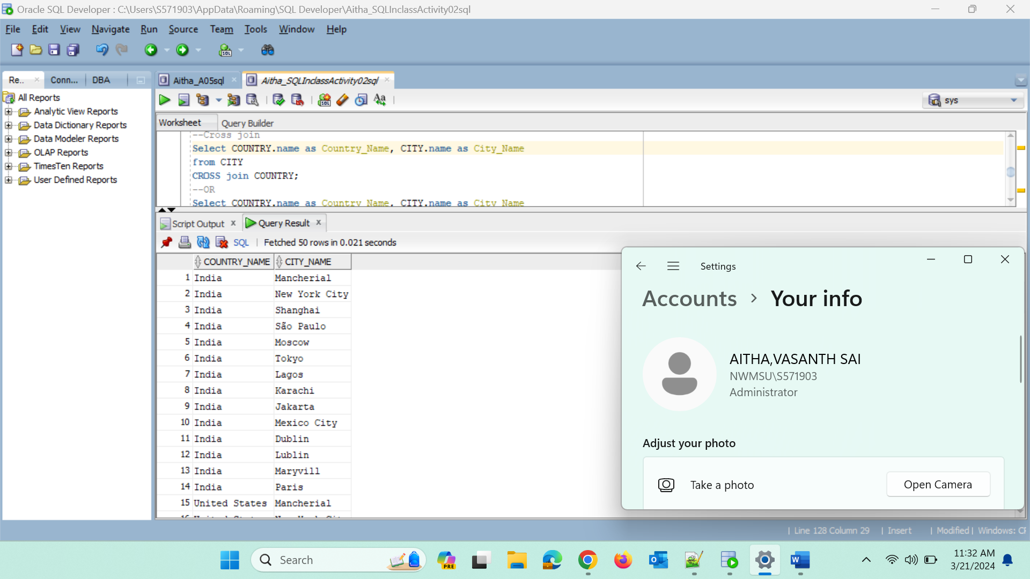

**-Natural join**

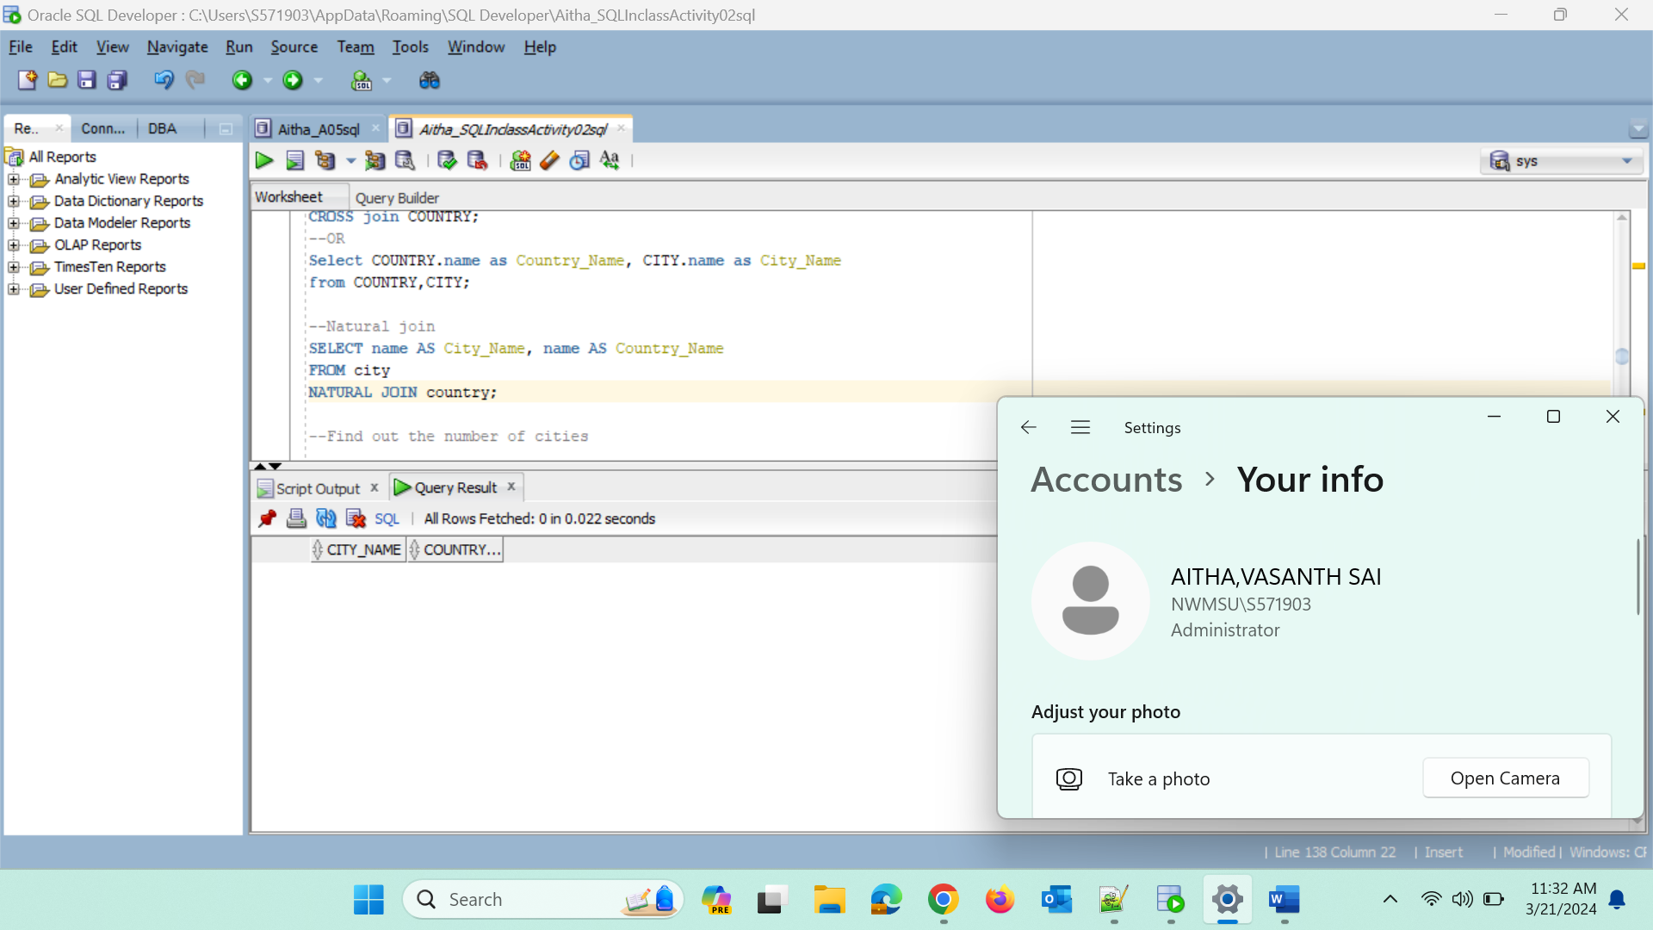

**--Find out the number of cities**

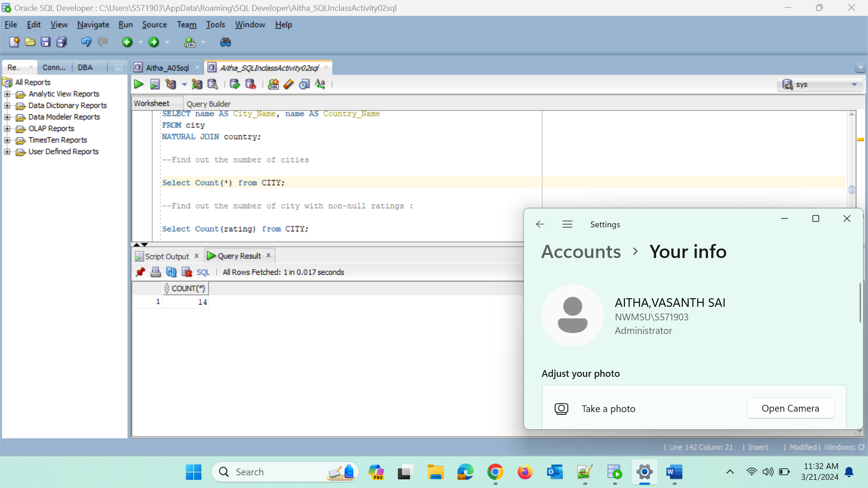

**--Find out the number of city with non-null ratings :**

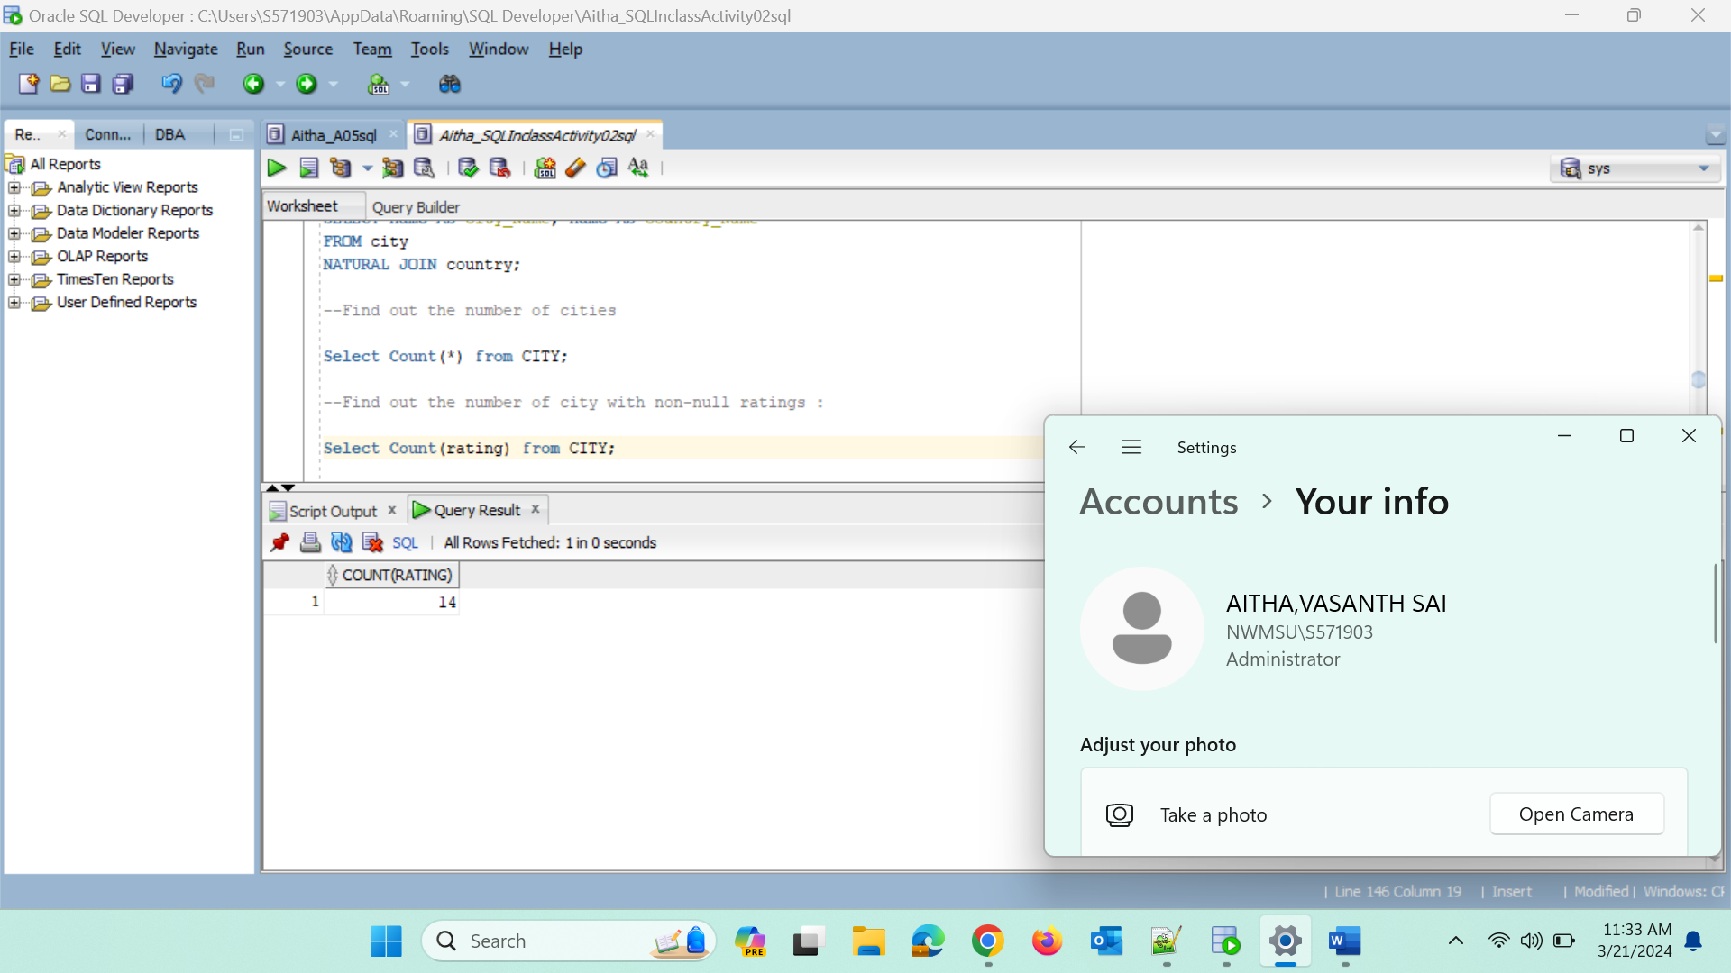

**----Find out the number of Distinctive country values:**

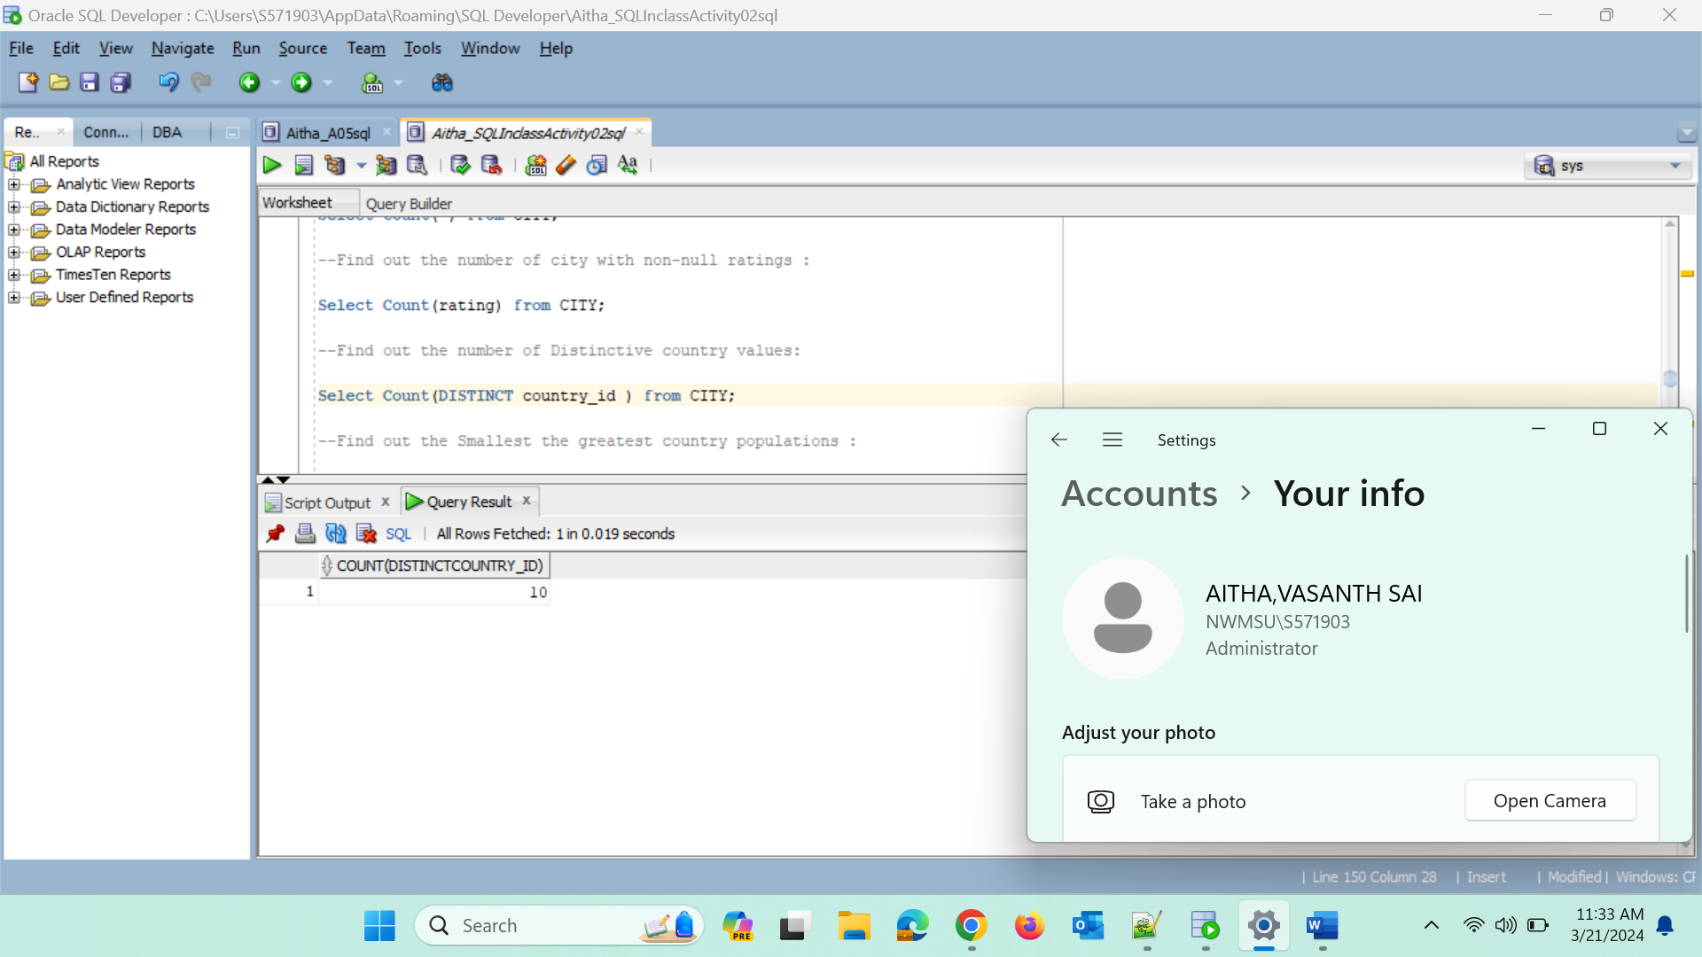

**--Find out the Smallest the greatest country populations :**

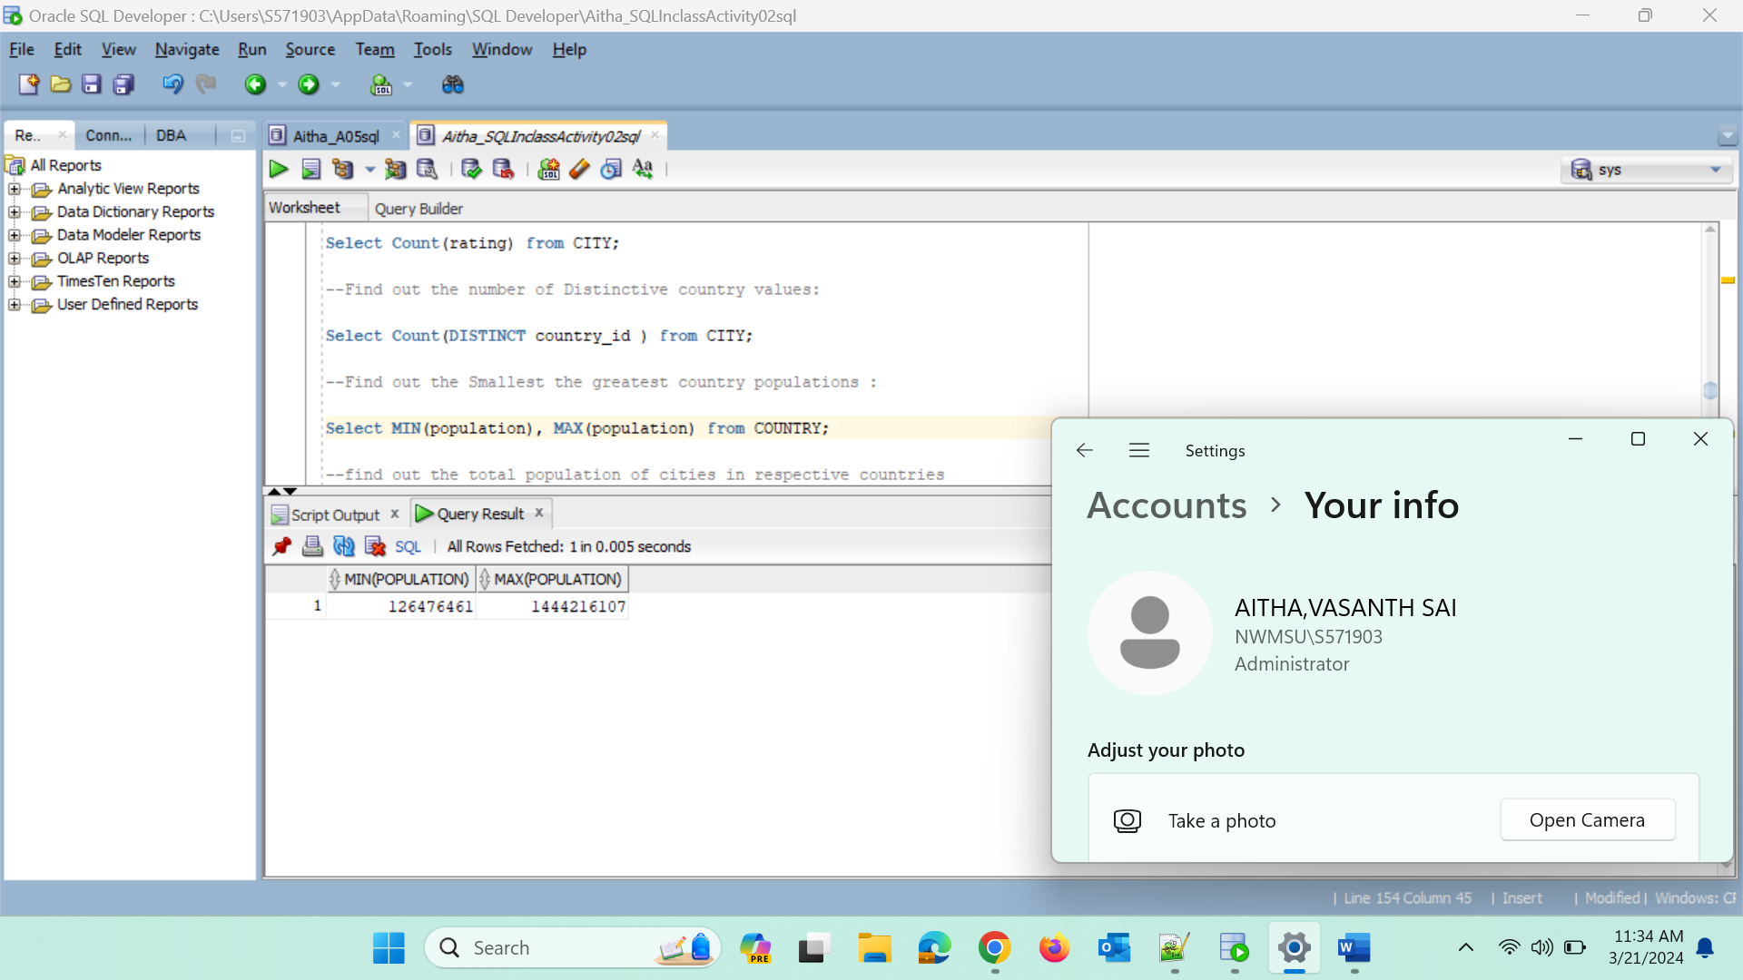

**--find out the total population of cities in respective countries**

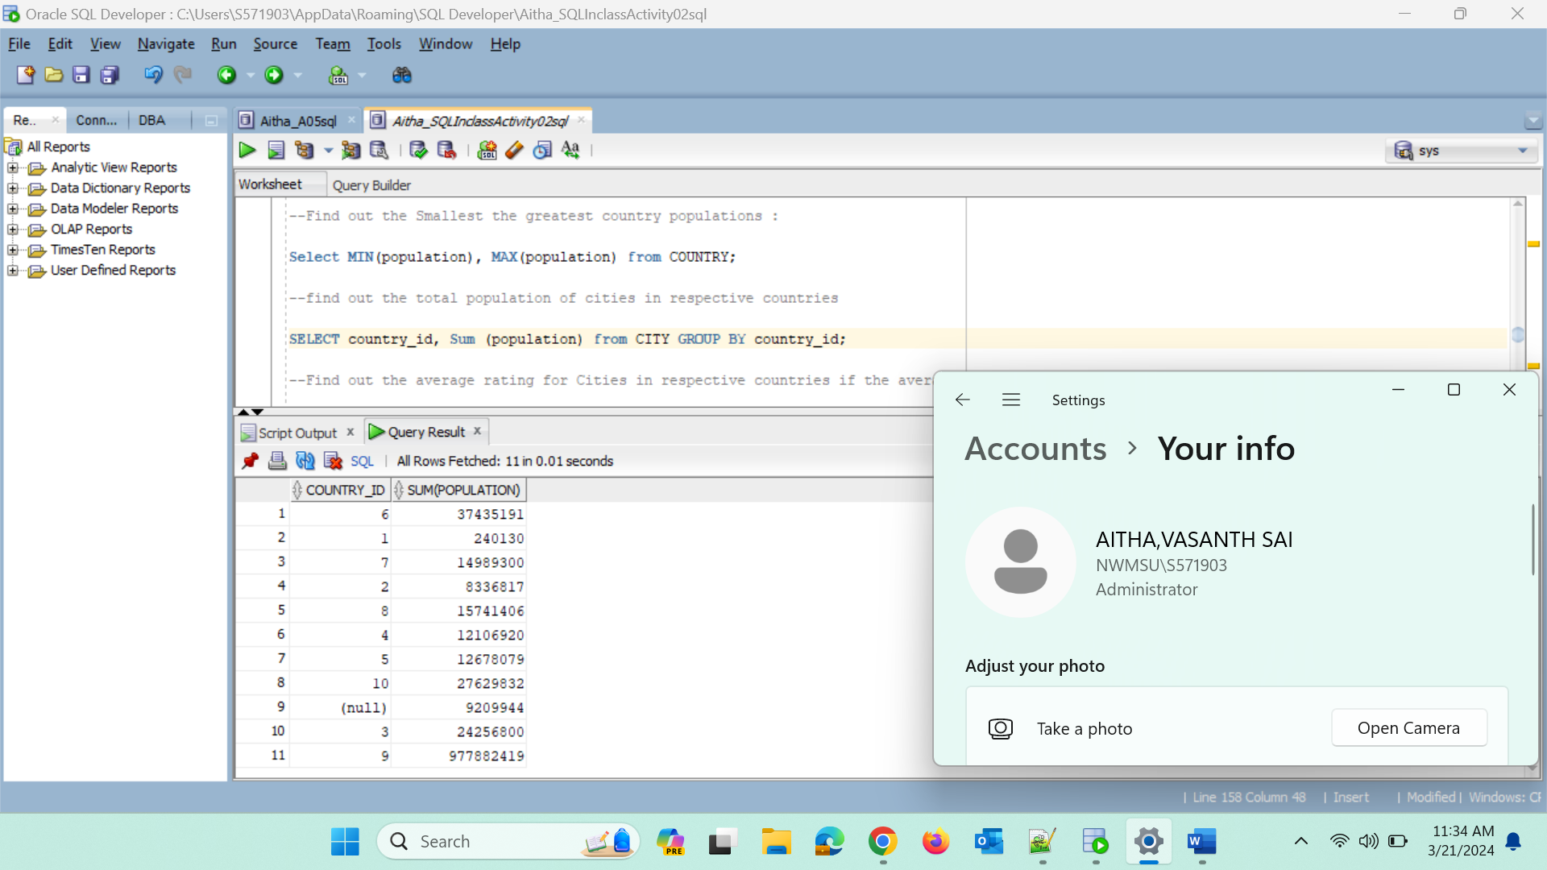

**--Find out the average rating for Cities in respective countries if the average is above 3.0;**

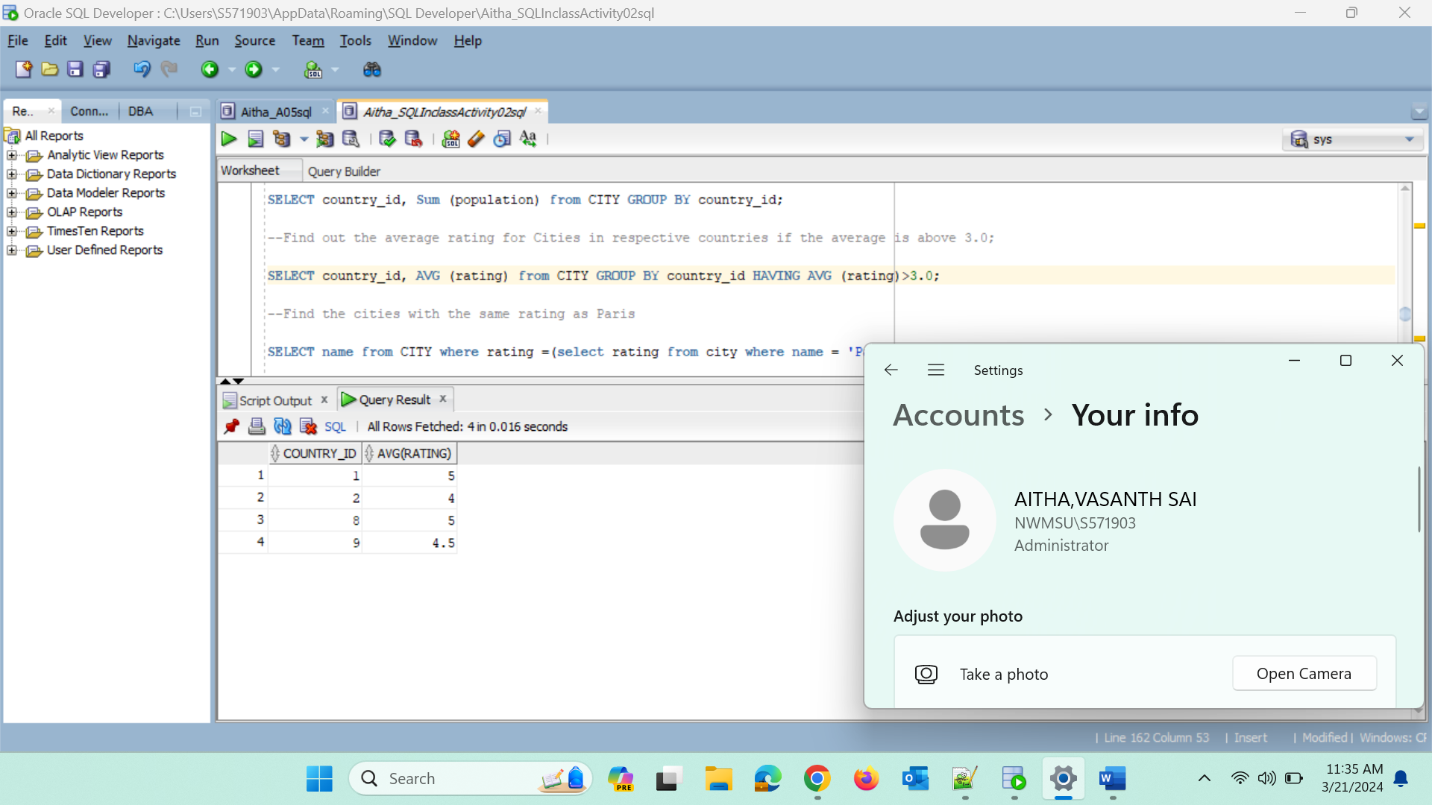

**--Find the cities with the same rating as Paris**

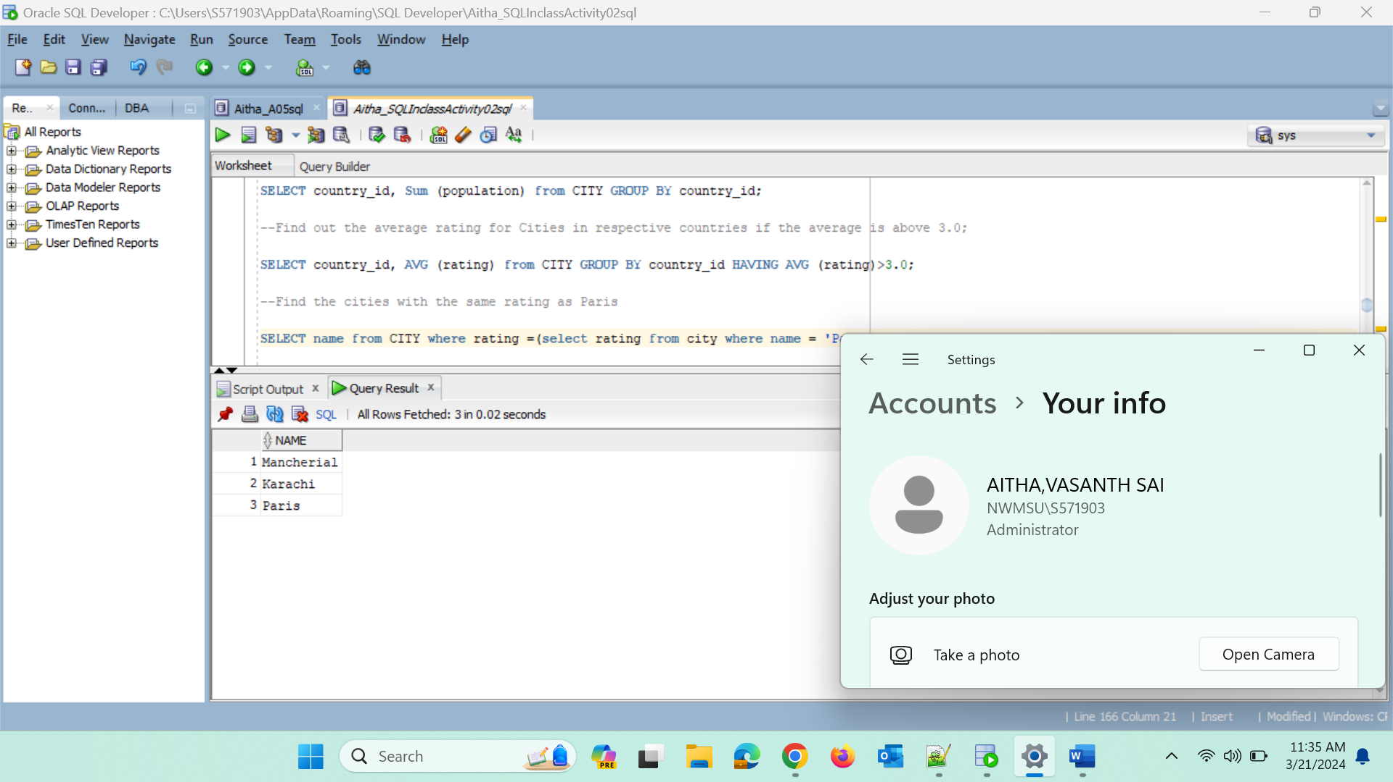

**--the Cities in countries that have a population above 20M:**

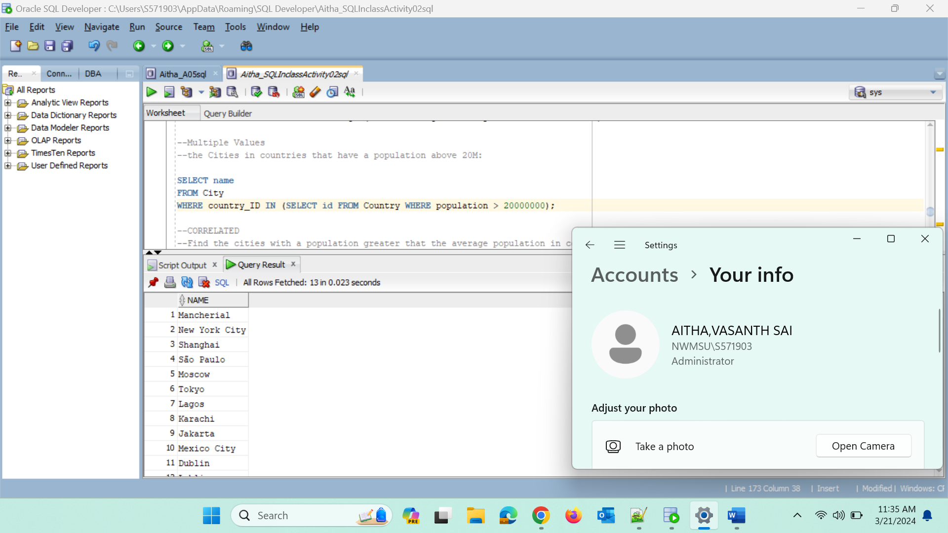

**--Find the cities with a population greater that the average population in country**

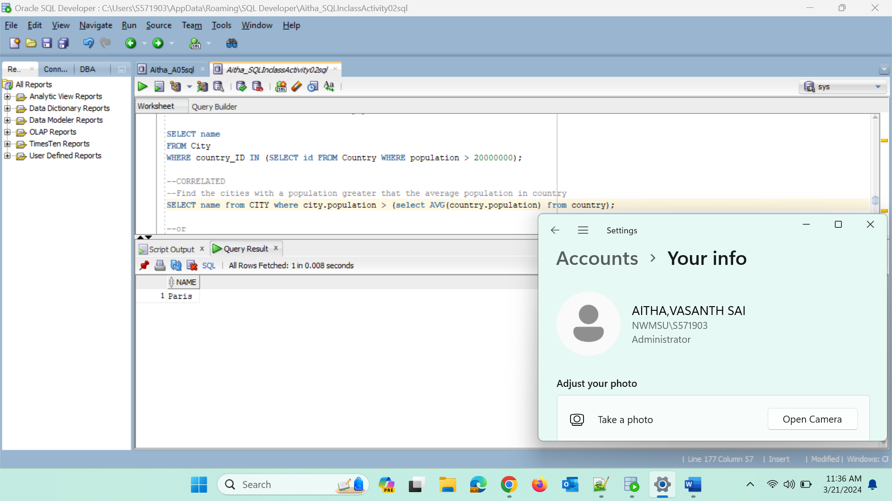

**--Find the cities with a population greater that the average population in country**

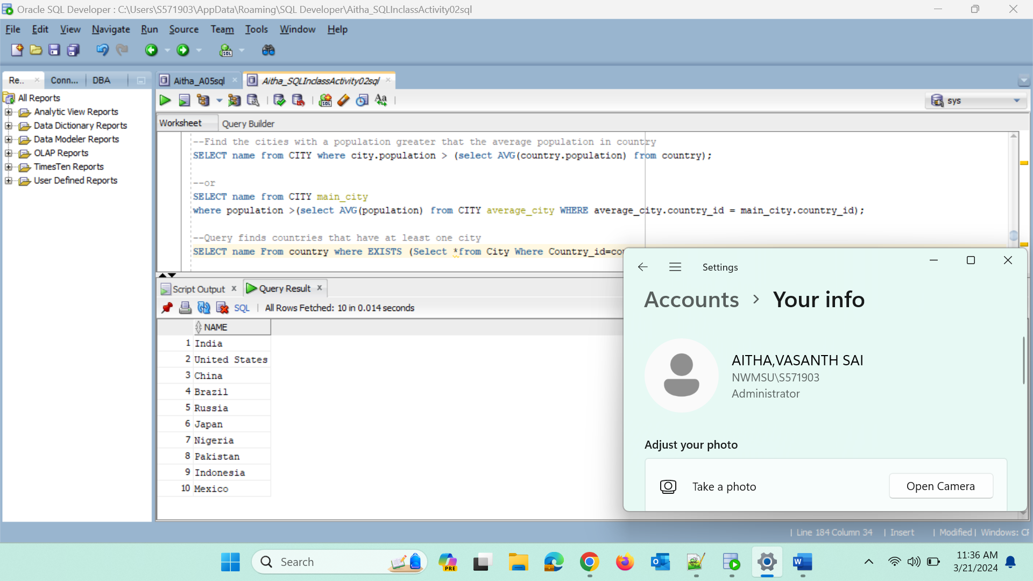

**--Query finds countries that have at least one city**

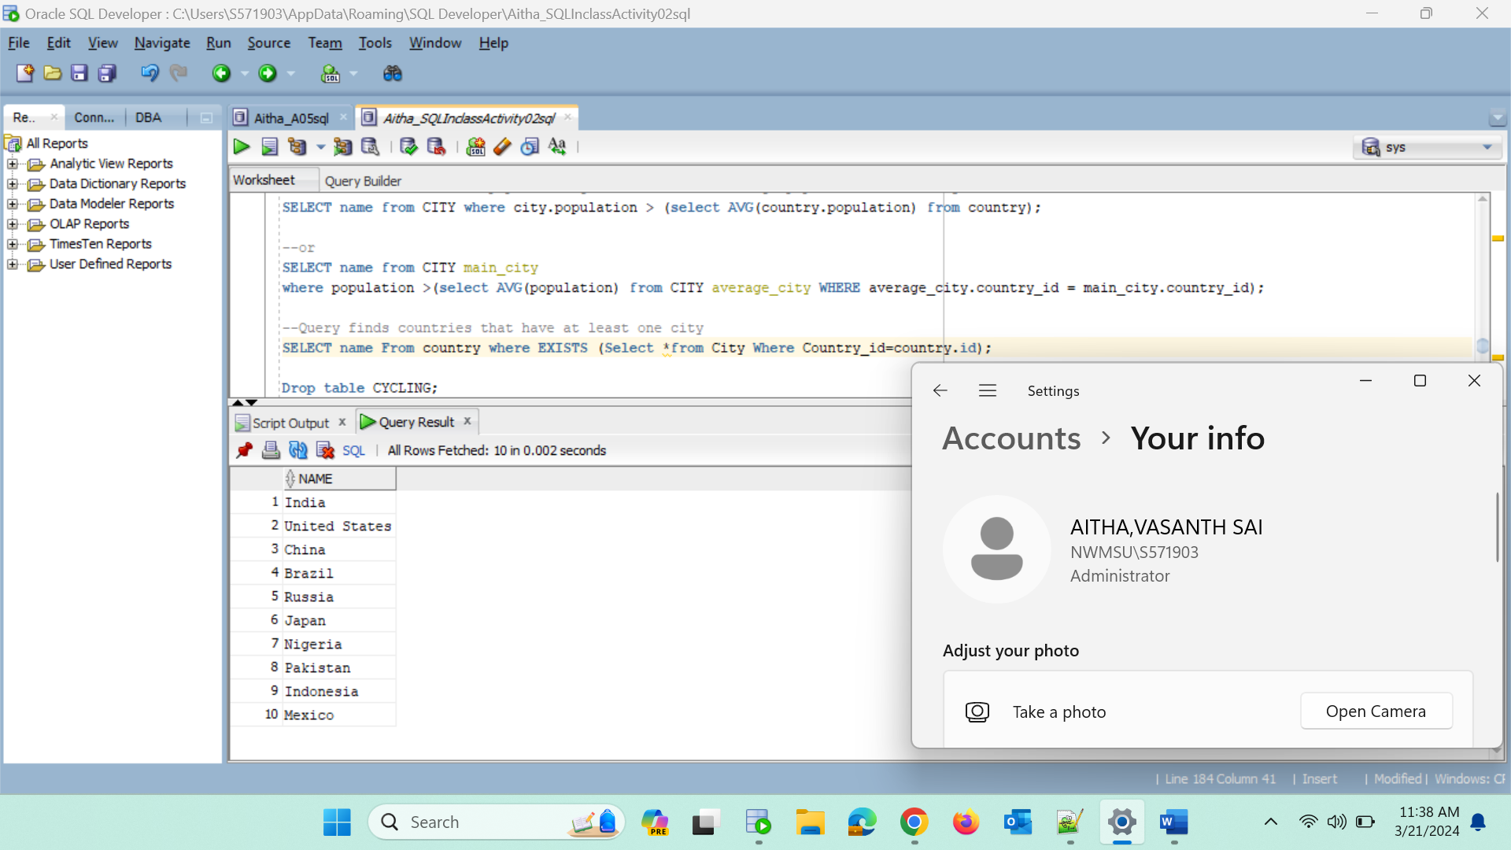

**--The query displaying German cyclists together with German Skaters:**

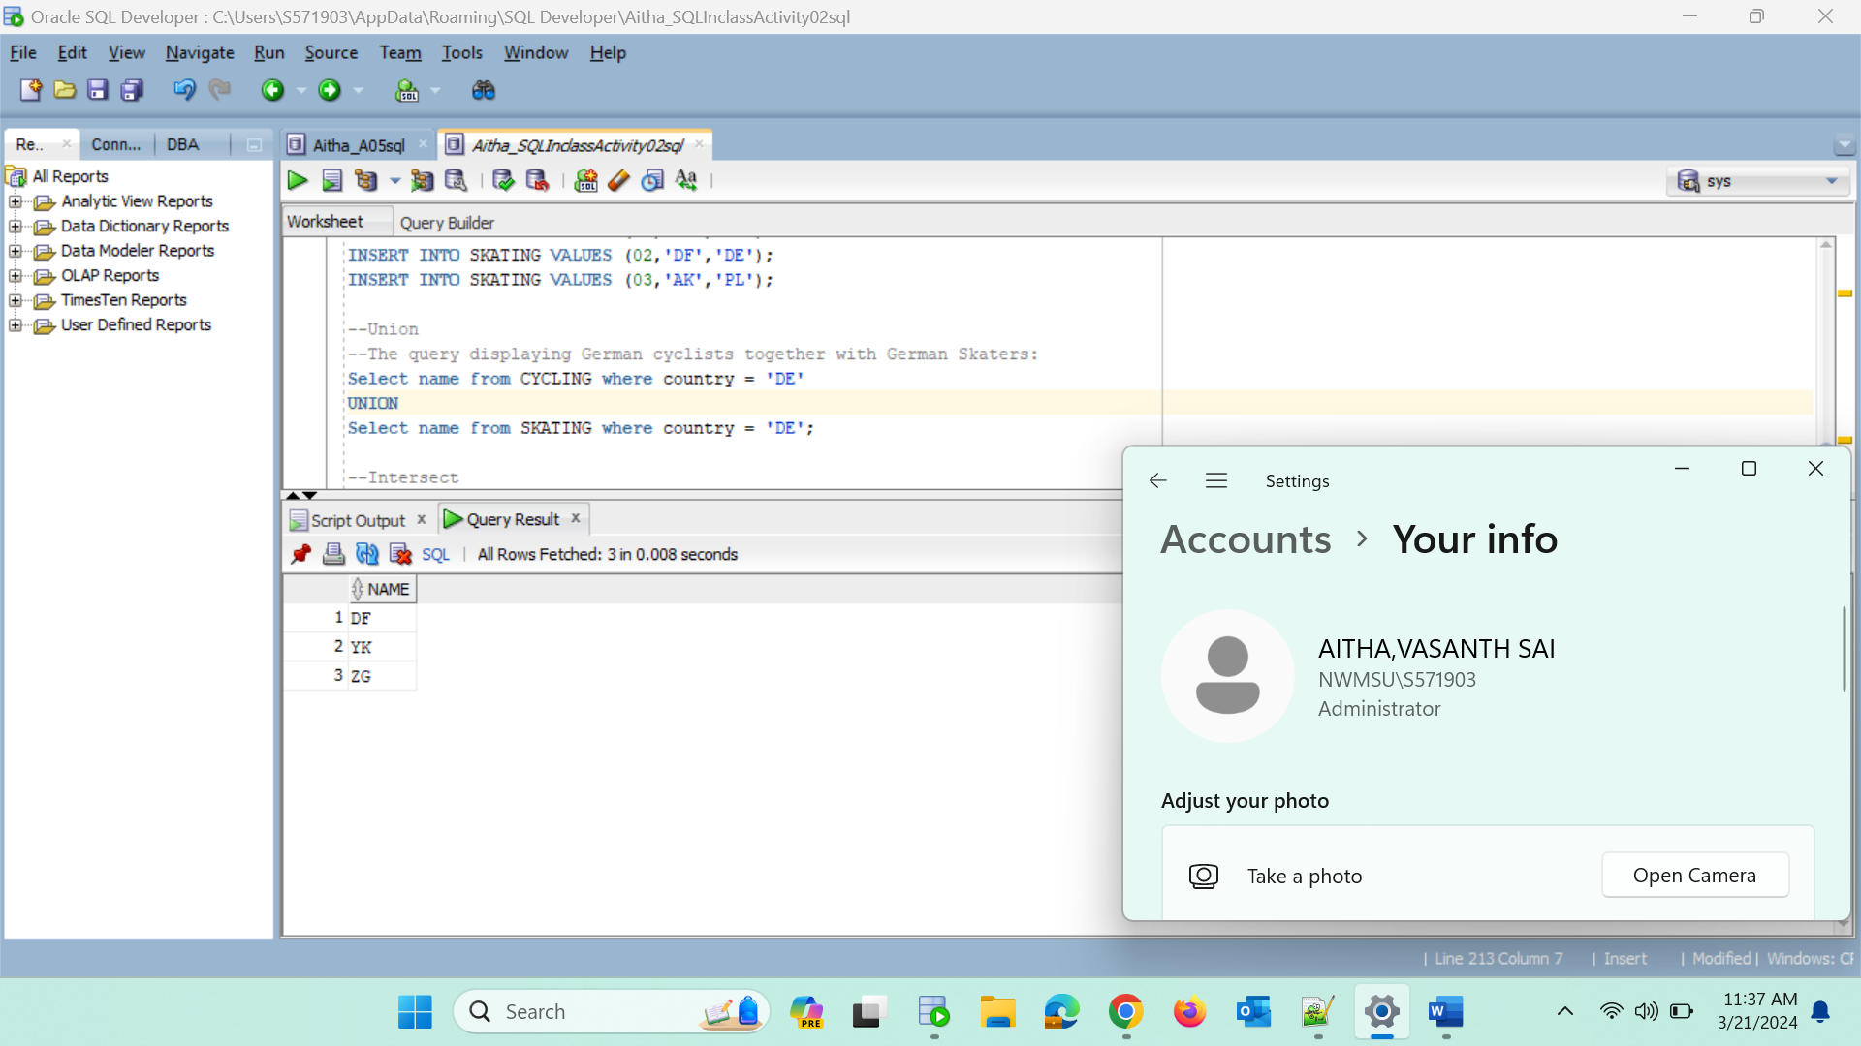

**Intersect**

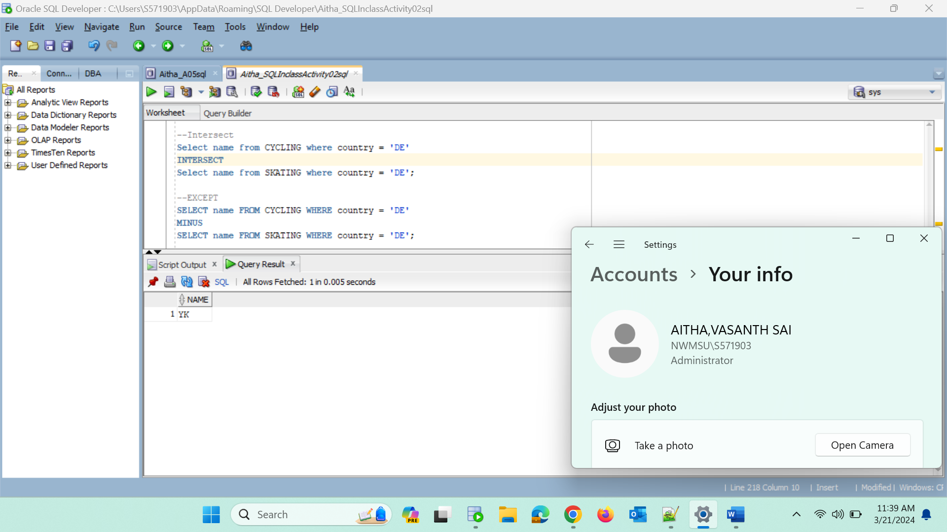

**EXCEPT**

